**Data Resources – Understanding, Creating, and Interpreting Graphs**

**Texas Population Pyramids Exercise**

***Objectives:***

* ***Use place-based learning to understand population pyramids and changes in Texas and Harris County***
* ***Become familiar with making graphs and using data in Microsoft Excel***

**Go to:** [**https://demographics.texas.gov/Infographics/2021/CBEstimates.aspx**](https://demographics.texas.gov/Infographics/2021/CBEstimates.aspx)

**Part I: State**

Students can play with years to look at temporal/time changes over the last decade.

People from around the country and world are migrating into TX, but why is school age populating growing so quickly in TX relative to other places?

Go to 2020 for the year, and then unclick “non-Hispanic” box. Have students observe the overall population vs. the Hispanic aged population to help answer.

Other things to check out: Breaking the pyramid up by generation (button at top) to discuss things in historical context and what was happening in the world.

**Part II: Harris County**

Go to Texas Counties at the top. Go to 2020. Note what the shape of the pyramid looks like for the state as whole.

Have students observe the median age for some of the counties (Harris, Dallas, Tarrant, and along the southern border).

Compare what’s happening in these urban and border regions with trends in the state. Why might the age distributions be different in some of these areas?

*Optional: If you want students to learn how to download and organize data, they can download it all and do that for any county in Texas. However, the files have several hundred rows. So, we have already downloaded and cleaned the data in an Excel file for Harris County. If you want them to go straight to using Excel, skip to the next part (under the next bold heading).*

*To do this for more place-based learning, under “Select one or more counties” unselect all and then scroll down and select just “Harris.”*

Have students work on making their own bar charts by either raw population or percentage for Harris County using the Excel file provided or using the data they download and organize.

**Step by step instructions here for graphing the data in Excel:**

1. Open the file *Harris_Age_Pyramid_data.xlsx*
2. Make sure you’re on the 2020Data worksheet (look at bottom)
3. To make population pyramids, you can either use the percent total of the population or the number of individuals in each category.
4. First, we’ll get the percentages in.
   1. To do this, sum the total amount of males and females
      1. For females, in cell E21, enter the formula: =Sum(E3:E20)
      2. For males, in cell L21, enter the formula: =Sum(L3:L20)
      3. Each cell now displays the total number of males and females in Texas based on the 2020 data
   2. Next, we need to get the percentage that each age group makes up for both males and females
      1. For females, in cell F3, enter the formula: =E3/$E$21
         1. *Note that the dollar signs in the formula above tells Excel to keep using that same cell over and over. So, here, we’re telling Excel to keep using the total population to calculate the percentage*
      2. You can enter the same formula over and over again referencing the cell next to it (E3, E4, E5, etc.). But, we’re not going to do that because Excel allows us to do things faster! So, use the cursor to hover over cell F3 until you see a black plus sign like this: **+**. Click the plus sign, and drag down the cursor into cell F20. With one simple click and drag, you’ve now copied the formula instead of typing it 18 separate times.
      3. Next, we’ll do the same thing for males. In cell M3, enter the formula: =L3/$L$21.
      4. Click and drag the formula down through cell M20 similar to what you did with the formula for % females.
   3. Alright, now you’re ready to learn how to make some graphs in Excel.
   4. To the right of where you entered the percent formulas, you’ll notice two sets of data: One for graphing the raw population numbers and one for graphing the percentages. First, we’ll make a population pyramid like on the TX state website with the raw numbers. *Note: The data is set up like this because Excel is less glitchy when everything is in columns right next to each other. Also, the male numbers have been made negative just for graphing purposes.*
      1. First, take your cursor (make sure it’s a white plus sign) and click and drag from cell P2 through cell R20.
         1. Leave the data highlighted and go up to the top of the Excel menu and find “Insert” and click it. Next, within the Insert menu, find the bar chart icon since population pyramids are bar charts.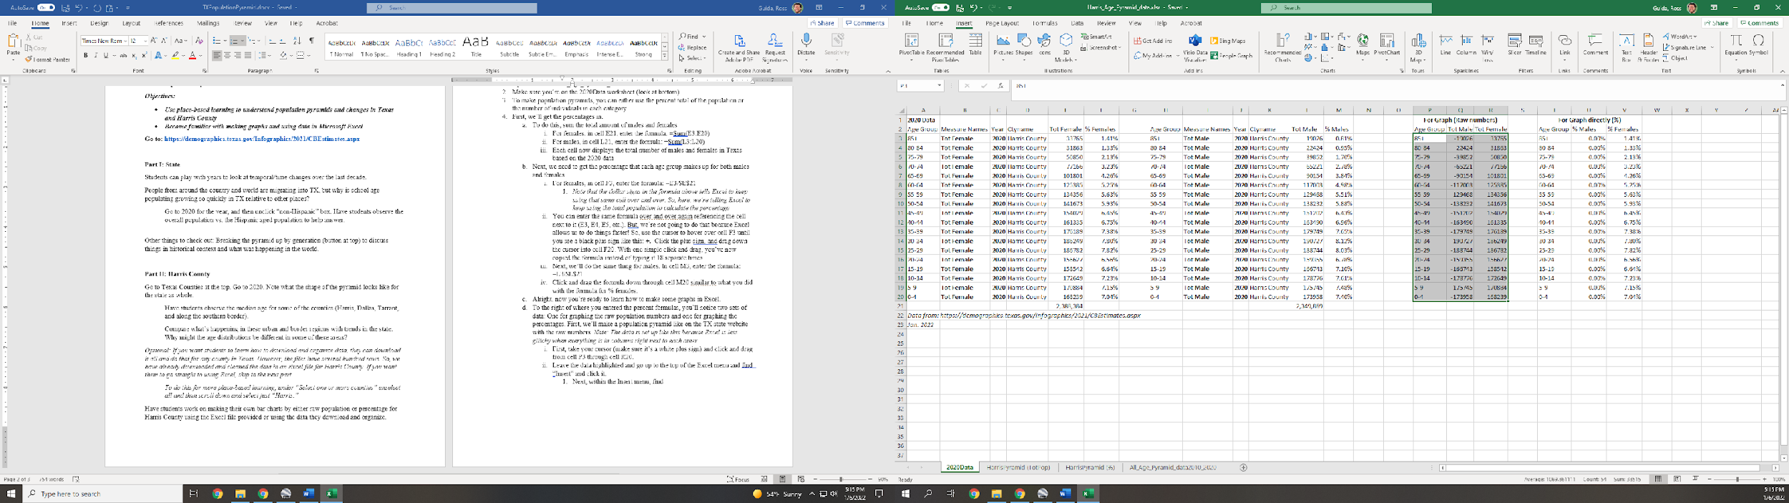
         2. Click the second chart under 2-D bar for a stacked bar chart.
         3. Next, move the chart to its own sheet so it’s bigger and easier to edit. To do this, click on the chart and hit “Move chart” in the menu bar at the top. Or, you can right click in the white space and also find “Move chart.”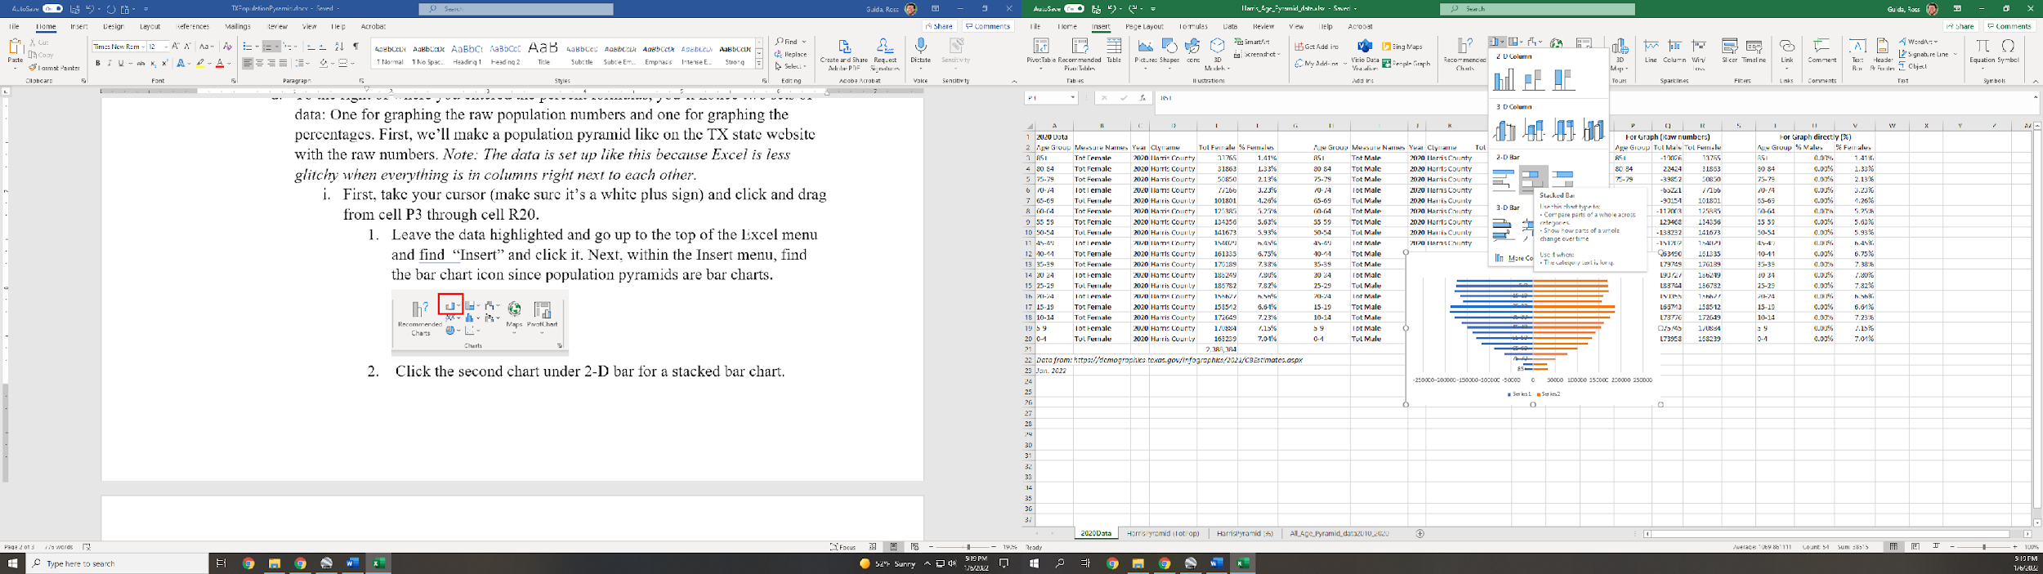
            1. Click the new sheet button. Type in a name of: HarrisPyramid (TotPop)
            2. Click OK.
         4. This doesn’t look like the population pyramid online yet, right? Well, time to edit.
            1. First, right click the numbers for the ages in the middle of the graph and go to “Format Axis.”

Go to Labels. Where it says “Next to Axis,” change this to “Low.”

Under Axis options, check the box that says “Categories in Reverse Order” to put older ages at the top and younger at the bottom.

Next, right click a number along the x (or horizontal axis) and hit format axis. Got to Labels, and change the label position from “Next to Axis” to “High.”

Alright, to get it to look more like a traditional pyramid, right click one of the colored bars in the middle and pick “Format Data Series.”

You should see an option to change the Gap Width. Change it to 5%.

To change the colors of your bars, right click and change the fill color to what you’d like

Lastly, give your chart a title that accurately reflects the data you’re displaying and what year it’s from.

* + - 1. To graph the percentages, highlight the percent data and follow the same steps you did from 1-4.
      2. When you’re done, your two graphs should look similar to the below.

